**Static volume provisioning:**

* PV means the storage chunks. PVC is a request made for the storage for PODs.

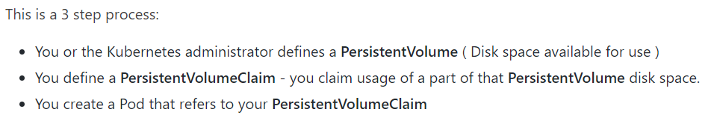

**Manifest:**

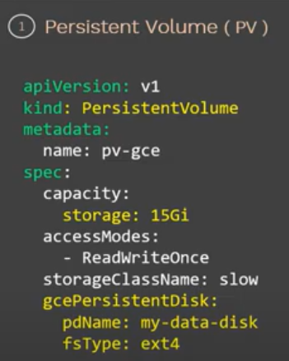

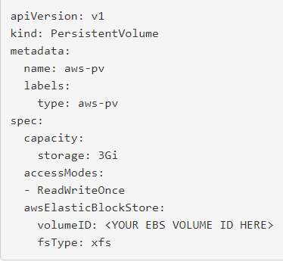

* There are different accessmodes in PV such as “read write once”, “read only many” & “read write many”.
* We have given “ReadWriteOnce” means the data can be read and write by a single node.
* Then the storage class name we need to give based on the type of storage we have created.
* If we have SSDs, then we can give here as fast. If we have regular magnetic disks, then we can define it as slow. This play a major role while creating PVC.

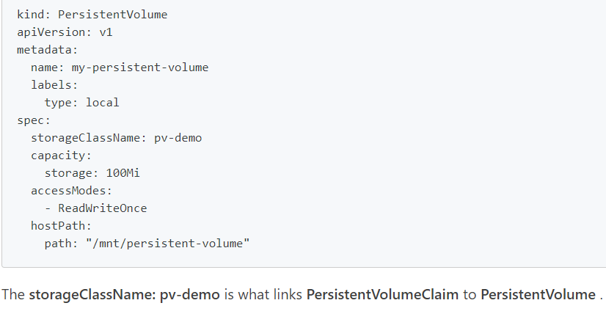

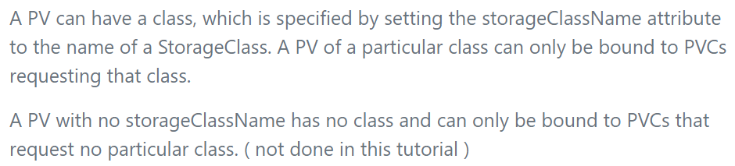

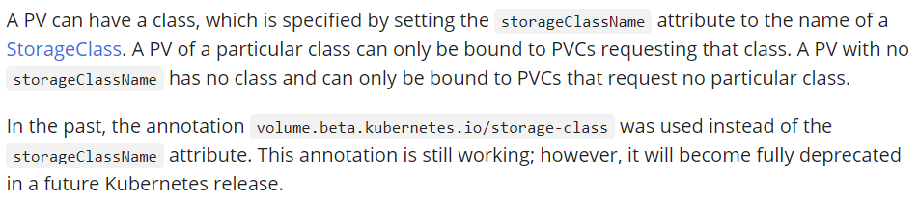

**Access modes:**

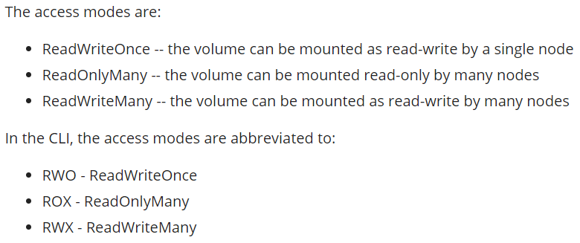

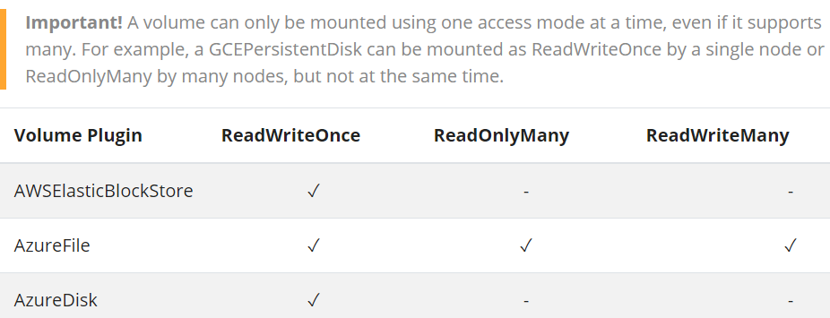

**Create PV:**

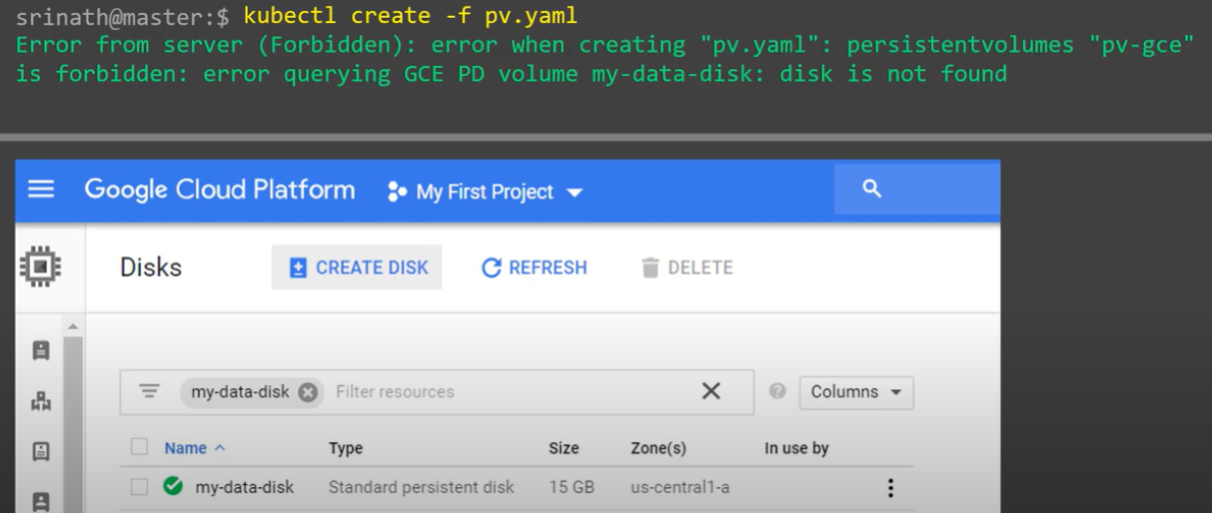

* It would fail because the disk volume which we created should be equal to the size of PV or may be little more than that will also be fine.

**Reclaim policy:**

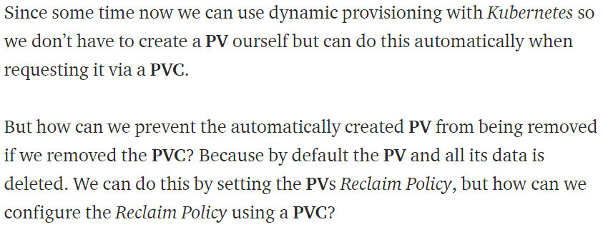

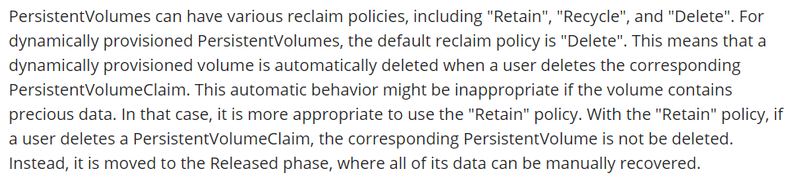

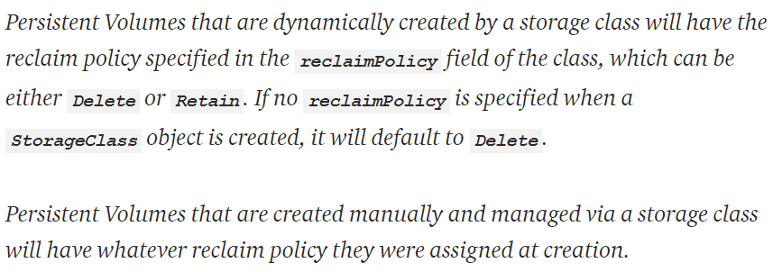

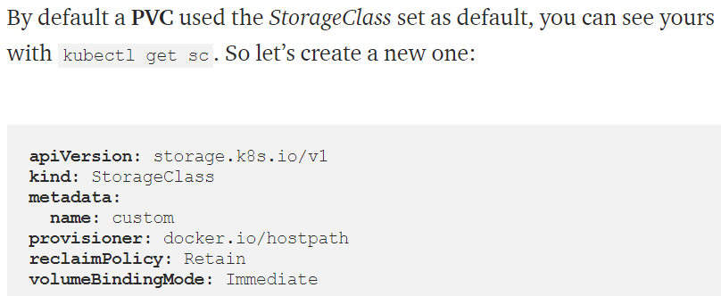

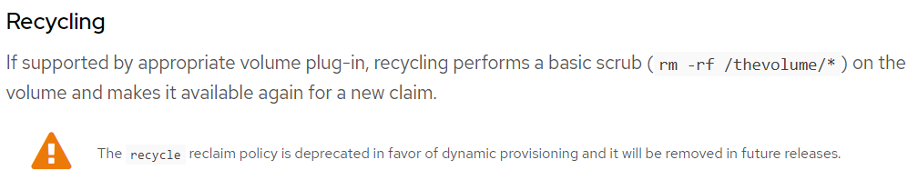

**Describe PV:**

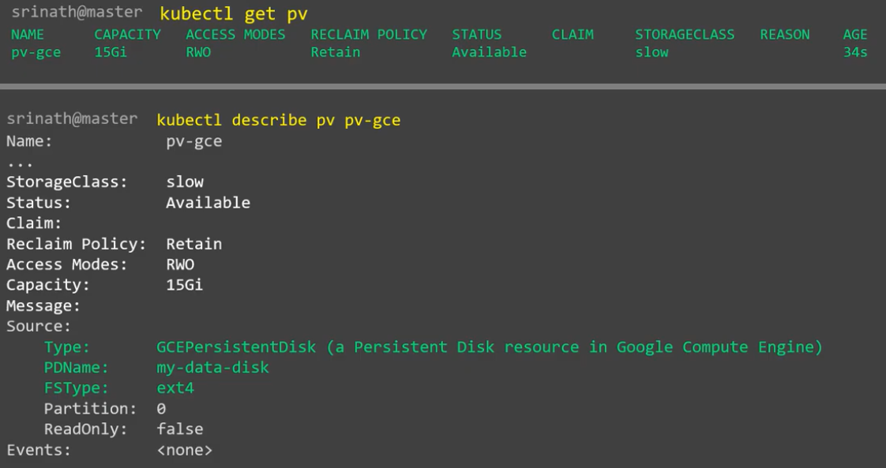

**Manifest for PVC:**

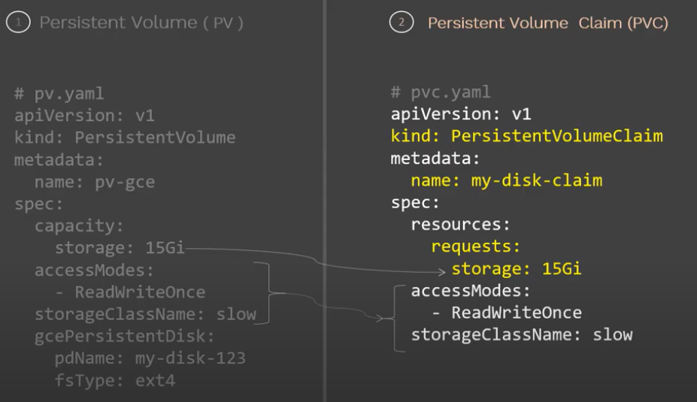

* If we don’t give **“storageClassName”,** the PVC will not get bound to the PV.

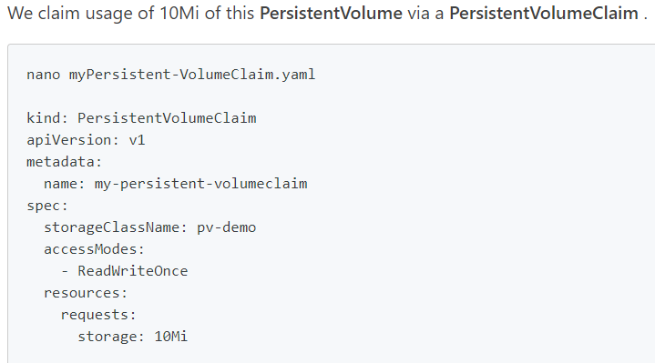

**Create & display:**

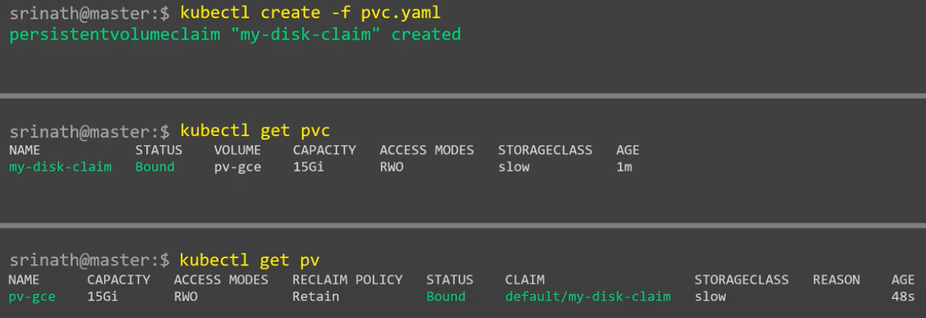

**POD manifest file:**

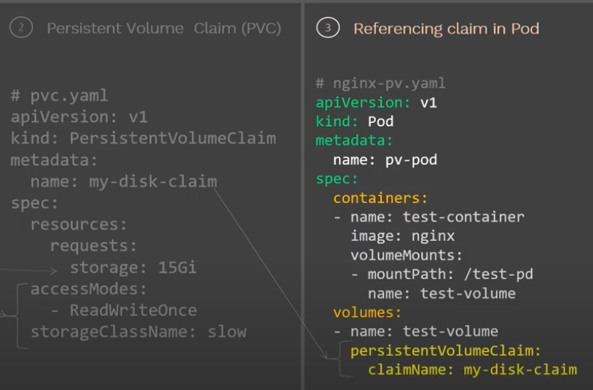

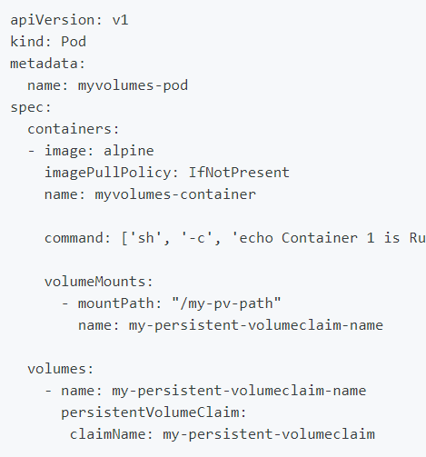

**Create & display POD:**

